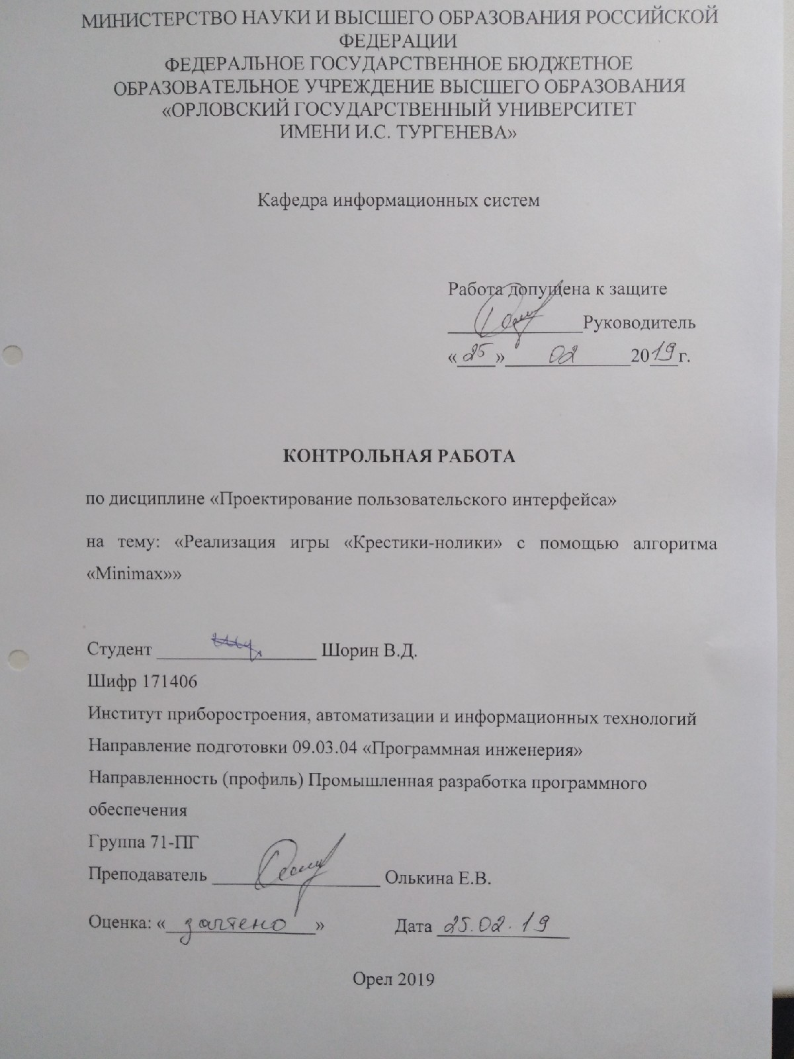

**Задание на контрольную работу**

Реализовать игру «Крестики-нолики» против компьютера, действующего по алгоритму «Minimax». Использовать графический интерфейс. Все действия осуществляются мышью.

**Листинг программы**

#include "windows.h"#include <cstdio>#include <algorithm> #include <limits>

struct Move{int x;int y;};

BOOL RegClass(WNDPROC, LPCTSTR, UINT);

LRESULT CALLBACK WndProc(HWND, UINT, WPARAM, LPARAM);

HINSTANCE hInstance;

char szMainClass[] = "MainClass";

char szMainTitle[] = "Cross-Zero";

void DrawLine(HDC, int, int, int, int);

void DrawGameField(HDC);

void DrawCross(HDC, int, int);

void ComputerTurn(HDC);

BOOL isSquareFree(int, int);

BOOL isTie();

BOOL isWinner(char);

Move Minimax();

int MaxSearch();

int MinSearch();

HWND hwnd;

char gameField[3][3] = {' ', ' ', ' ', ' ', ' ', ' ', ' ', ' ', ' '};

char symbol;

int xMouse, yMouse;

bool isComputerTurn = false;

int WINAPI WinMain(HINSTANCE hInst, HINSTANCE hPrevInstance, LPSTR lpCmdLine, int nCmdShow){

MSG msg;

hInstance = hInst;

if (!RegClass(WndProc, szMainClass, COLOR_WINDOW)) { return FALSE; }

const int w = 308, h = 330;

int x = (GetSystemMetrics(SM_CXSCREEN) - w) / 2;

int y = (GetSystemMetrics(SM_CYSCREEN) - h) / 2;

hwnd = CreateWindow(szMainClass, szMainTitle,

WS_VISIBLE | WS_SYSMENU | WS_MINIMIZEBOX,

x, y, w, h, 0, 0, hInstance, NULL);

if (!hwnd) { return FALSE; }

while (GetMessage(&msg, 0, 0, 0)) {

if (isComputerTurn) {

HDC hdc = GetDC(hwnd);

ComputerTurn(hdc);

}

if (isWinner('X')) {

MessageBox(hwnd, "Player wins", "Winner", MB_OK);

SendMessage(hwnd, WM_CLOSE, 0, 0);

}

if (isWinner('O')) {

MessageBox(hwnd, "Computer wins", "Winner", MB_OK);

SendMessage(hwnd, WM_CLOSE, 0, 0);

}

if (isTie()) {

MessageBox(hwnd, "Its tie", "Tie", MB_OK);

SendMessage(hwnd, WM_CLOSE, 0, 0);

}

TranslateMessage(&msg);

DispatchMessage(&msg);

}

return msg.wParam;

}6

BOOL RegClass(WNDPROC Proc, LPCTSTR szName, UINT brBackground){

WNDCLASS wc;

wc.style = CS_HREDRAW | CS_VREDRAW;

wc.cbClsExtra = 0;

wc.cbWndExtra = 0;

wc.lpfnWndProc = Proc;

wc.hInstance = hInstance;

wc.hIcon = LoadIcon(NULL, IDI_APPLICATION);

wc.hCursor = LoadCursor(NULL, IDC_ARROW);

wc.hbrBackground = (HBRUSH)(brBackground + 1);

wc.lpszMenuName = (LPCTSTR)NULL;

wc.lpszClassName = szName;

return (RegisterClass(&wc) != 0);

}

LRESULT CALLBACK WndProc(HWND hWnd, UINT msg, WPARAM wParam, LPARAM lParam){

HDC hdc; PAINTSTRUCT ps;

switch (msg) {

case WM_LBUTTONDOWN: {

xMouse = LOWORD(lParam);

yMouse = HIWORD(lParam);

hdc = GetDC(hWnd);

if (isSquareFree(xMouse, yMouse)) {

DrawCross(hdc, xMouse / 100, yMouse / 100);

symbol = 'X';

gameField[xMouse / 100][yMouse / 100] = symbol;

}else{

char str[64];

sprintf(str, "There is already cross/zero \nPlease, try again", xMouse / 100, yMouse / 100);

MessageBox(hWnd, (LPCTSTR)str, "XY", MB_OK);

}

isComputerTurn = true;

break;

}

case WM_PAINT: {

hdc = BeginPaint(hWnd, &ps);

DrawGameField(hdc); //Отрисовка поля

EndPaint(hWnd, &ps);

break;

}

case WM_DESTROY:{PostQuitMessage(0);return 0; }

}

return DefWindowProc(hWnd, msg, wParam, lParam);

}

//Отрисовка линии

void DrawLine(HDC hdc, int left, int top, int right, int bottom) {

MoveToEx(hdc, left, top, NULL);LineTo(hdc, right, bottom);}

//Отрисовка игрового поля

void DrawGameField(HDC hdc) {

DrawLine(hdc, 100, 0, 100, 300);DrawLine(hdc, 200, 0, 200, 300);

DrawLine(hdc, 0, 100, 300, 100);DrawLine(hdc, 0, 200, 300, 200);

}

//Отрисовка креста

void DrawCross(HDC hdc, int left, int top){

DrawLine(hdc, left * 100, top * 100, (left + 1) * 100, (top + 1) * 100);

DrawLine(hdc, left * 100, (top + 1) * 100, (left + 1) * 100, top * 100);

}

//Ход компьютера

void ComputerTurn(HDC hdc){

if (isTie()) {

MessageBox(hwnd, "Its tie", "Tie", MB_OK);

SendMessage(hwnd, WM_CLOSE, 0, 0);

}

Move computerMove = Minimax();

Ellipse(hdc, computerMove.x * 100, computerMove.y * 100, (computerMove.x + 1) * 100, (computerMove.y + 1) * 100);

symbol = 'O';

gameField[computerMove.x][computerMove.y] = symbol;

isComputerTurn = false;

}

BOOL isSquareFree(int _xMouse, int _yMouse){

if (gameField[_xMouse / 100][_yMouse / 100] != 'O'

&& gameField[_xMouse / 100][_yMouse / 100] != 'X')

{ return true; }

else { return false; }

}

BOOL isTie(){

for (int i = 0; i < 3; i++) {

if (gameField[i][0] == ' ' || gameField[i][1] == ' ' || gameField[i][2] == ' ')

{ return false; }

}

return true;

}

BOOL isWinner(char player){

for (int i = 0; i < 3; i++) {

for (int i = 0; i < 3; i++) {

if (gameField[i][0] == player && gameField[i][1] == player && gameField[i][2] == player)

{ return true; }

if (gameField[0][i] == player && gameField[1][i] == player && gameField[2][i] == player)

{ return true; }

}

if (gameField[0][0] == player && gameField[1][1] == player && gameField[2][2] == player)

{ return true; }

if (gameField[0][2] == player && gameField[1][1] == player && gameField[2][0] == player)

{ return true; }

return false;

}

}

Move Minimax(){

int score = (std::numeric_limits<int>::max)();

Move move;

for (int i = 0; i < 3; i++) {

for (int j = 0; j < 3; j++) {

if (gameField[i][j] == ' ') {

gameField[i][j] = 'O';

int temp = MaxSearch();

if (temp < score) {

score = temp;

move.x = i;

move.y = j;

}

gameField[i][j] = ' ';

}

}

}

return move;

}

int MaxSearch(){

if (isWinner('X')) { return 10; }

else if (isWinner('O')) { return -10; }

else if (isTie()) { return 0; }

int score = (std::numeric_limits<int>::min)();

for (int i = 0; i < 3; i++) {

for (int j = 0; j < 3; j++) {

if (gameField[i][j] == ' ') {

gameField[i][j] = 'X';

score = (std::max)(score, MinSearch());

gameField[i][j] = ' ';

}

}

}

return score;

}

int MinSearch(){

if (isWinner('X')) { return 10; }

else if (isWinner('O')) { return -10; }

else if (isTie()) { return 0; }

int score = (std::numeric_limits<int>::max)();

for (int i = 0; i < 3; i++) {

for (int j = 0; j < 3; j++) {

if (gameField[i][j] == ' ') {

gameField[i][j] = 'O';

score = (std::min)(score, MaxSearch());

gameField[i][j] = ' ';

}

}

}

return score;

}